Mesh Configuration File
The purpose of the mesh configuration file is to provide E4D with instructions concerning how to build the mesh. The mesh configuration file is comprised of five blocks, each of which are described below. As with all E4D input files, blank lines are allowed. Comments are also allowed on each line where an input value is specified, at any position on the line after the input value. The mesh configuration file must be named <ert_mesh>.cfg, where <ert_mesh> is a user chosen mesh file name.

General Block
The general block provides instructions concerning mesh quality, lower boundary elevation, and the locations of the tetgen and triangle. The format of the general block is provided in the table below, with each row of the table representing a corresponding row in the mesh generation file. The only record required on each line is the specified variable (i.e., the first column), and comments may be added after each variable.

Variable | Type | Description
m_qual | real number | The maximum radius-to-edge ratio of any element in the mesh (see tetgen documentation).  Recommended values are in the range of 1.3 to 1.5, with 1.3 specifying a higher quality mesh
max_evol_def | real number | Default maximum volume of all elements in the mesh. Maximum volumes for each zone are specified using mz_vol (see zone configuration block below)
m_bot | real number | Elevation of the bottom of the computational mesh.
tet_build_flag | integer (0 or 1) | If 0 is specified, E4D will build the .poly input file for tetgen, but will not call tetgen to build the mesh. If 1 is specified, E4D will call tetgen to build the mesh
tet_loc | String | This variable specifies the location of the tetgen executable, and must be enclosed in single quotes. For example, if tetgen is located in /usr/e4d_qc/bin/tetgen, then tet_loc is '/usr/e4d_qc/bin/tetgen'. If /usr/e4d_qc/bin is in the executable path, then 'tetgen' will suffice
tri_loc | string | The variable specifies the location of the triangle executable, and be enclosed in single quotes. For example, if triangle is located in /usr/e4d_qc/bin/triangle, then tri_loc is '/usr/e4d_qc/bin/triangle/'. If /usr/e4d_qc/bin is in the executable path, then 'triangle' will suffice

Control Points Block
Those points that are required to define mesh geometry, including surface topography, electrode locations, internal boundaries (e.g., non-point electrodes, buried infrastructure, known geologic contacts), and mesh refinement points are specified as control points within the control points block. Each control point will become a mesh node in the final tetrahedral mesh. There are three types of control points:
- Surface points are used to specify points of known elevation and/or surface electrode locations on the mesh, and are given a flag of 1. E4D, triangle, and tetgen use these points to define surface topography and add nodes at surface electrode locations. Surface points cannot be placed on or beyond the outer boundary of the mesh (see Figure 1), which is specified by a set of surface boundary points, as described below.
Surface boundary points are used to define the outer boundary of the computational mesh, and are given a flag of 2 (see Figure 1). E4D uses these nodes to construct the outer vertical boundaries of the computational mesh by connecting adjacent points and constructing a series of vertical planes down to the elevation m_bot, which is specified in the general block.
In run modes ERT1, SIP1 outer boundaries are zero potential boundaries and should be positioned a large distance away from the electrode array.
In run modes ERTtank1 and SIPtank2, the outer tank wall boundaries are close enough to the electrodes to influence the data. A flag=2 sets these nodes as zero flux boundaries.
Internal control points are used to define internal boundaries, buried electrode locations, and mesh refinement points, and are given a flag of 0 unless they are used to define a metallic boundary.
Within the imi module:
Internal control points that are used to define a metallic boundary are assigned a negative integer, with each unique metallic boundary (point, line, plane, or volume) having a unique negative flag. All internal control points must be placed within the mesh boundaries formed by the surface boundary, vertical external boundaries, and bottom boundary (Figure 1)
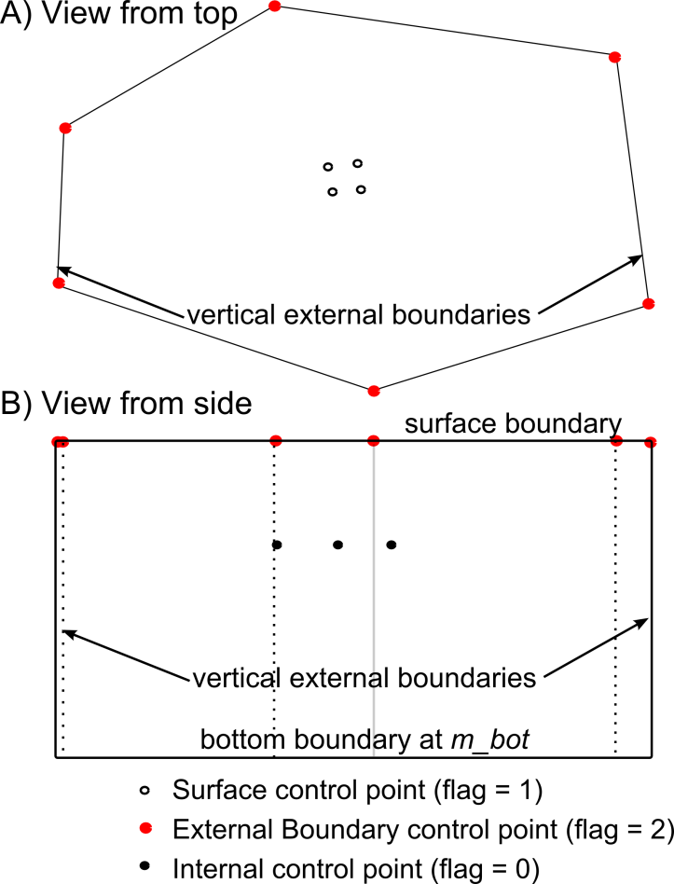
Figure 1. Diagram of the three types of control points used to define a mesh
It is best practice to place a control point at every electrode location, although it is not explicitly required by E4D. E4D 'snaps' each electrode to the nearest node in the mesh. If the nearest node is far from the actual electrode location, modeling errors may result (E4D will print a warning message in modes ERT2 and higher if this occurs).

The format of the control point block is as follows:
Variable | Type | Description
n_cpts | positive integer | specifies the total number of control points
cp_num x y z b_flag | see description | cp_num is a positive integer value that gives the index of the  control points specified on this line. The cp_num values should be numbered consecutively from 1 to n_cpts. cp_num can be used to identify a particular control point used in a boundary definition as described in the internal boundary control block below.  x y and z are real valued numbers that give the easting, northing and elevation positions of control point cp_num respectively.  b_flag is an integer value that provides the boundary flag for the control point specified on this line as described above.  There will be n_cpts of these lines in the control points block, one for each control point.
It is generally beneficial to refine the mesh near electrodes in order to improve modeling accuracy. For buried electrodes, this can be done by placing a second control point near each electrode control point. By so doing, tetgen will refine around the two points, as is required, to maintain a high quality mesh. The mesh can be refined around surface electrodes in the same manner. Another approach to refine around surface electrodes is to place each just under the surface with a boundary flag of b_flag = 0. By doing so, tetgen will automatically refine around each surface electrode. This practice also facilitates high quality surface mesh generation by removing the requirement to have a node at every electrode location on the surface (i.e., the electrodes are placed just beneath the surface).

Internal Boundary Configuration Block
Internal boundaries consist of one or more user-defined internal planes (called piecewise linear complexes in the tetgen documentation) that separate one region of the mesh from another. Internal boundaries that close to form a 'watertight' structure form a zone within the mesh. Boundaries are specified by describing how selected control points are connected to form planes within the internal boundary configuration block as follows:
Variable | Type | Description
n_plc | non-negative integer | total number of user-defined piecewise linear complex's  (i.e. planes)
np b_num | see description | np is the number of control points used to define this plane  (there will be one np value listed for each of the n_plc planes  defined)  b_num is the user specified boundary number for this plane.  This integer can be any value except 0, 1, or 2, which are  reserved within E4D. Set b_num >2 unless this boundary is  an infinite conductivity (i.e. metallic) boundary, in which case  b_num should be set to the same negative integer as b_flag,  where b_flag is the boundary flag specified for each of the np  control points used to defined this plane, as listed on the next  line. All boundaries sharing the same negative b_num value  are modeled as infinite conductivity and electrically  connected structures within E4D.  This line is the beginning of a plane definition. There will be n_plc of lines in the internal boundary configuration block.
p1 p2 ... p_np | non-negative integer | p* is the *th control point defining this plane. This value references the control point indexes specified in the control points block. Control points must be specified in order to define a plane such that no segment connecting two consecutive control points crosses any other segment connecting two consecutive control points (i.e list the control points either clockwise or counter-clockwise). E4D does not check this condition prior to executing tetgen, and tetgen will fail if this condition is violated. Also, each of the points specified must lie in the same plane according to numerical precision or tetgen will fail.  This line is the end of a plane definition. There will be  n_plc of lines in the internal boundary configuration block.

Critical boundary definition rules
The most common source of error in mesh generation is the improper specification of internal boundaries. If tetgen fails and the source of the error is not obvious from the mesh.log file, make sure the boundary definitions in the boundary configuration block adhere to the following requirements.
- Do not define planes on any external boundary (e.g., surface, bottom, or side boundaries). E4D will construct these automatically. It is appropriate and required to explicitly specify segments of subsurface planes that intersect the surface boundary within the boundary definition (see item 5 below).
- Ensure that boundaries do not intersect, except along common segments. Such intersections will cause tetgen to fail, and E4D does not check for this condition.
- All control points existing within a defined plane, or along any segment of of a defined plane, must be included in the definition of that plane.
- Each of the control points used in the plane definition must lie upon the same plane. This is important if four or more points are used to define a plane.
- There are several import considerations when constructing boundaries that intersect the surface.
- The segments of any plane that intersect the surface boundary must be explicitly specified in the plane definition. In other words, any plane segment that intersects the surface boundary must not be defined by the first and last points specified in the plane definition (i.e. the points defining segments on the surface must be listed sequentially in the plane definition).
- It is often useful to specify a series of planes that form a closed boundary (thereby forming a zone) whose upper margin is the surface of the mesh, which is automatically generated by E4D (see item 1 above). In this case E4D must correctly connect the segments of planes intersecting the surface such that those segments define the upper boundary of the zone. To do so, E4D takes the list of control points defining the segments that intersect the surface, and connects each point to the next nearest point. With this in mind, it is important to define the planes that intersect the surface in such a manner that E4D correctly connects the surface segments. Attention to this issue is only required for boundaries whose surface intersection forms convex angles.
It is generally helpful and highly recommend to draw a picture with relevant control points labelled to ensure that boundary definitions do not violate these conditions.

Hole Configuration Block
Any zone defined within E4D can be turned into a hole or void in the mesh. To create a hole, tetgen begins at one point within the subject zone and successively removes all of the elements enclosed within the zone boundary. The hole configuration block specifies which zones should be hollowed to form a hole by specifying a point within the zone as follows:
Variable | Type | Description
n_holes | non-negative integer | specifies the number of holes in the mesh
hn xh yh zh | see description | hn is the index for this hole.  xh yh and zh are real valued numbers indicating the  easting, northing, and elevation of any point within this hole  There are n_holes of these lines, one for each hole, and hn should range from 1 to n_holes.
Three-dimensional metallic structures should be defined as holes in E4D, so that only the shell of the structure exists in the mesh. This is done by specifying a hole point inside of a zone constructed using planes with the same negative boundary flag as described above.

Zone Configuration Block
The zone configuration block assigns maximum element volumes, conductivity values, and zone numbers to each zone.
The format of the zone configuration block for run modes ERT1 and ERTtank1 is as follows:
Variable | Type | Description
n_zones | positive integer | number of user-defined zones
zn xz yz zz mz_vol zcond | see description | zn is the zone number assigned to this zone.  xz yz zz is the position of any point within this zone  mz_vol is the maximum volume of any point within this zone  zcond is the conductivity of this zone  There are n_zones of these lines, one for each zone in the mesh. These lines should be listed consecutivelyfrom zn = 1 to zn = n_zones.

The format of the zone configuration block for run modes SIP1 and SIPtank1 is as follows:
Variable | Type | Description
n_zones | positive integer | number of user-defined zones
zn xz yz zz mz_vol zreal zimag | see description | zn is the zone number assigned to this zone.  xz yz zz is the position of any point within this zone  mz_vol is the maximum volume of any point within this zone  z_real is the real conductivity of this zone  z_imag is the imaginary conductivity of this zone  There are n_zones of these lines, one for each zone in the mesh. These lines should be listed consecutivelyfrom zn = 1 to zn = n_zones.

Zones that are not configured will assume a maximum volume constraint of max_evol_def (see general block) and a default conductivity value. However, it is best practice to provide configuration options for each zone defined in the mesh.

Visualization Options Block
The visualization options block provides the option to automatically produce an exodus file for visualization once the mesh is generated as follows:
Variable | Type | Description
px_flag | integer value  (0 or 1) | specifies whether E4D should build a mesh visualization file (1) or not (0)
px_loc | string | specifies the location of the utility program px or bx. For example, if px or bx is located in /usr/e4d_qc/bin/, then bx_loc is '/usr/e4d_qc/bin/bx' (quotes are required). If /usr/e4d_qc/bin is in the executable path, then 'px' will suffice.

